Counting Pipeline (QUINT)
All zip files for the programs, macros, files and my template folder are in the “Counting_Pipeline” folder. For the folder organization the template folder names are used in this script.
Preprocessing
- Rename the images in the following manner: Condition/Animal-ID_section number e.g 7D_FS_s001, 7D_FS_s002,..,7D_FS_sXXX , if possible number the pictures from anterior to posterior (as it increases DeepSlice`s accuracy).
- Store all Images of one animal in the same folder.

Resize
- Open Nutil, press on “NEW” and select Resize
- Select the Input folder with the original Tiffs, as the output folder select the Resize Folder.
- The Resize factor stays at 25%
- Now press “Start”
Increase Contrast
- Open FIJI (ImageJ)
- Plugins > New > Marco
- Here select File > Open and open the contrast.ijm (you find it in the Macro sub-folder located in the Counting_Pipeline folder)
- Select the “Resize” folder as the input folder and the “Alignment” folder as the output folder and hit Run.
Deepslice (Allignment)
Option A: Local pipeline (for online alignment see Option B)
If you use the pipeline on a new device please execute the following section (first part in anaconda prompt only the first time on each device!!):
- Dowload Anaconda Navigator and Open it
- Before Opening make sure the YAML file „environment.yaml“ is in your LocalAdmin folder (no further sub-folder) or your currend working Directory
- Open the Anaconda Prompt in the anaconda navigator and copy following lines one by one.

- conda env create -f environment.yaml
- python -m ipykernel install --user --name DeepSlice2 --display-name "Python (DeepSlice2)"

- Close the Anaconda Prompt and open from Anaconda Navigator Jypiter Notebook
- In Jypiter notebook click on the top right corner on „New“ and then select the Python environment DeepSlice2
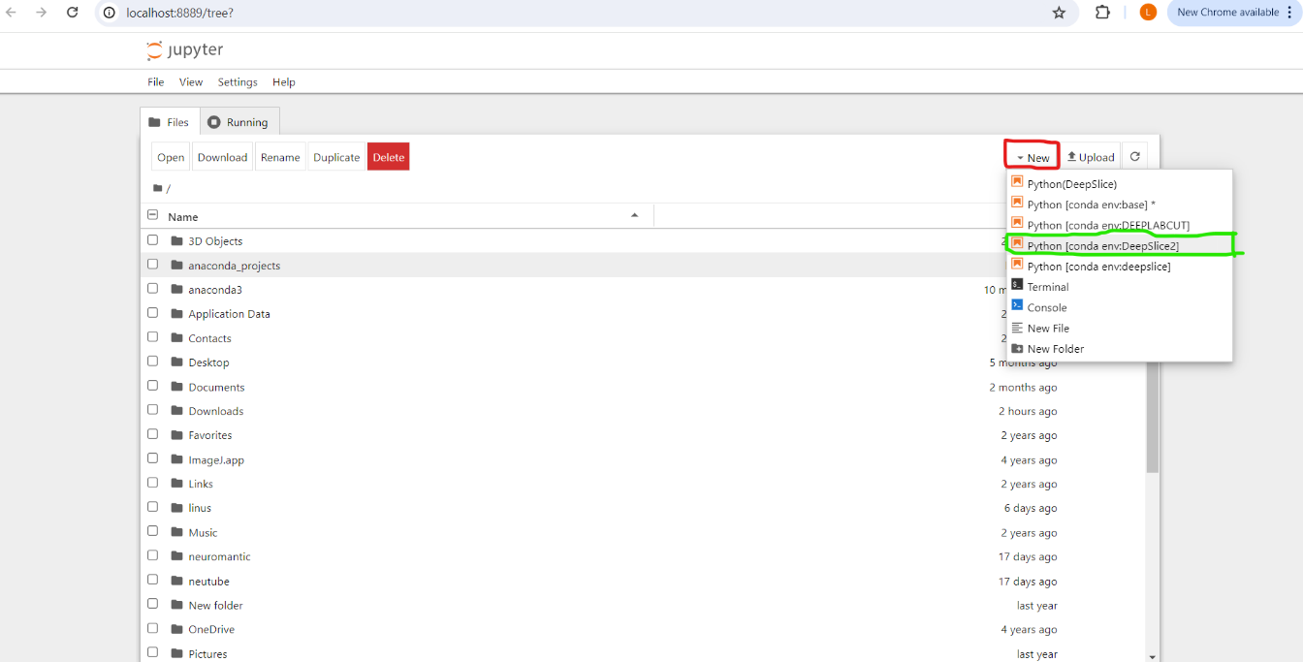
- Please insert,and run the following lines (Ctrl+Enter), each line in one cell please.
- Do consider that the Quality of the output depends on how well your slices are in order. If they are not in order please change section_numbers=False, insert the Folder with the higher contrast pictures at folderpath= /your/ path/ (This should be your alignment folder). As you are addressing a folder please take care your path ends with a slash „/“!!

- from DeepSlice import DSModel
- species = 'mouse'
Model = DSModel(species)
- folderpath = 'your/path/' #insert your “alignment” folder with increased contrasyt images
- Model.predict(folderpath, ensemble=True, section_numbers=True)
#if you work without section numbering or mounted in order please put section number=False
- Model.save_predictions(folderpath + 'MyResults') #the input folder is here also the output folder

- Now please safe the notebook and the next time you only have to reopen your notebook and run the lines, (the Anaconda code is not required anymore). The Kernel will automatically be set to the DeepSlice2 Kernel.
- If you want to do multiple Alignments runs without closing the notebook, just re-run line 3) and 4) and change the input folder.
Option B: Online Deepslice
- Go to the Deepslice webside ( https://www.deepslice.com.au/ )
- Chose all Images from the “Alignment” folder (resized+contrast enhanced)
- Select the boxes as show underneath but deselect Cutting Index due to issues with misalignments
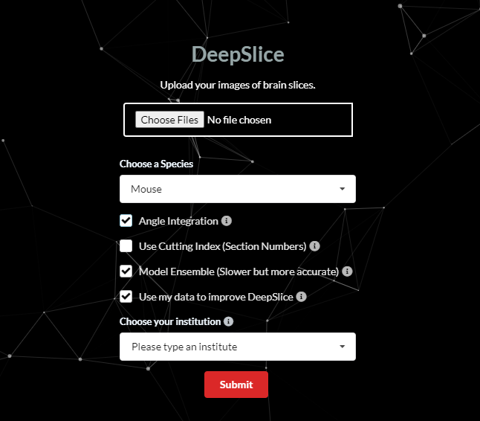

- Safe the file as JSON in your “Alignment” folder
Quick N2
- Open the JSON file created with DeepSlice and take adjustment if needed
- Open your data in the file manager
- Hit store if you finished the adjustment on the section to safe the adjustment of the slice
- Save the alignment as a JSON
VisuAlign
- Open the JSON file of QuickN2 and take nonlinear adjustments
- Place markers on the slice by pressing “space-bar” on your current pointer position, drag the mask in position to match the landmarks
- Save the JSON file AND export in the alignment folder.
Ilastik
Training:
- Only needed if you want to train a new model
- Load in images (non resized tiff preferably) which cover as many different cell shapes, cell density or intensities
- Go to feature selection and select all features
- Now Label your cells (yellow) and label the background (blue)
- To check the quality of your labeling activate live update make sure to also check for simple segmentation by checking the box in the left menu
- If you are satisfied with your model recognition of cells and background save your model first
(if you start with a pretrained model go to open file and open the ilastik project file.lip)
Batch processing:
- Now select exportation settings simple segmentation instead of probability.
- Open the extra exportation settings and select png as export formate and set the output folder to the “ilastik” folder
- The folder name should look something like this C:/Stress/7DFSW/F1/ilastik/{nickname} here it is crucial to put the magic word “{nickname}”. It will ensure that batch processing is possible and all pictures are safed with their input name.
- Now go to the 5th terminal “Batch processing” and input all the original tiffs that are in your base folder by selecting “inset Raw Images” and multiselect the folder content.
- Now press start “process al files”
Image J
- Open FIJI (ImageJ)
- Plugins > New > Marco
- Here select File > Open and open the timesafe.ijm (you find it in the Macro sub-folder located in the Counting_Pipeline folder)
- Select the “Ilastik” folder as the input folder, the lut file in the “Segment” folder (acounting.lut) and the “Segment” folder as the output folder then hit Run.
Nutil
- Press “New” and select Quantifier
- Name the Project as you wish (not important)
- Open the “Segment” folder as the Segmentation folder
- For Brain atlas map folder select the “Alignment” folder of the animal
- As the JSON anchoring file select the VisuAlign JSON file in the “Alignment” folder
- Please select an Output folder for the Nutil output
- Deactivate Object Splitting <Object Splitting:No> (for Nutil >1.0 select Counts instead of Area Fraction)
- If you don´t use coordinates later deactivate it to decrease processing time < Coordinate extraction:None> (coordinate extraction only possible on very good CPUs)
- Now hit Start and just name the Project file as you wish (again the file doesn´t matter)

